**Advanced Database System (Lab)**

**PRN:** 2122000567

**Name:** Sujay Sanjay Gangan

**Roll No.:** B35

**Experiment No.:** 01

**Problem Statement 1:**

Create Book Store database using complex data types such as structure, array and set. Solve the queries on that database.

**Description :**

Create Book Store database using below schema and insert at least 5-7 tuples in each table.

|  |  |  |  |  |
| --- | --- | --- | --- | --- |
| Table Name | Field | Data Type | Key | FK Reference |
| Author | author_id | varchar (10) | PK |  |
| name | Structured type (fname and lname) |  |  |
| Phone_no | Varray(4) |  |  |
| Book | ISBN | integer | PK |  |
| title | varchar (30) |  |  |
| author_id | vArray [10] |  |  |
| category | varchar (20) |  |  |
| publisher | Structured type (pub_id, Pub_name, branch) |  |  |
|  | keywords | multiset |  |  |
|  | price | Number (10,2) |  |  |
| Customer | customer_id | varchar (10) | PK |  |
|  | name | Structured type (fname and lname) |  |  |
|  | phone | multiset |  |  |
| Book­_Sale | sale_id | varchar (10) | PK |  |
|  | customer_id | varchar (10) | FK | Customer.customer_id |
|  | ISBN | integer | FK | Book.ISBN |

Creating Author Table:

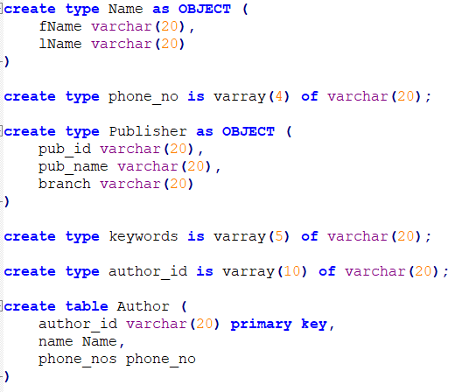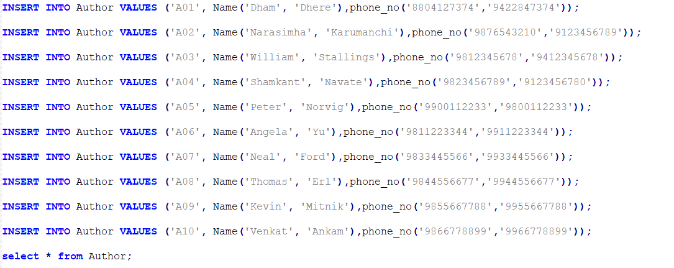

Creating Book Table:

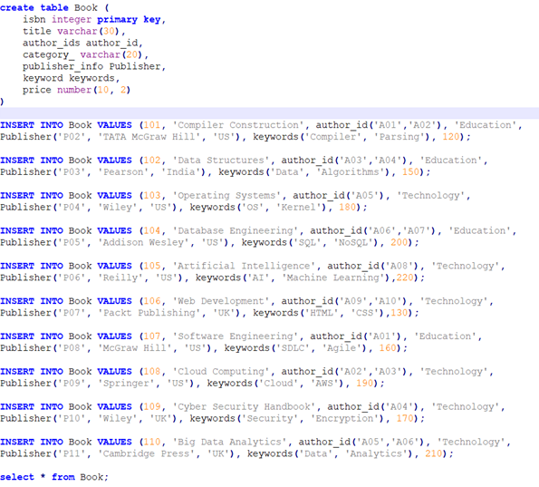

Creating Customer Table:

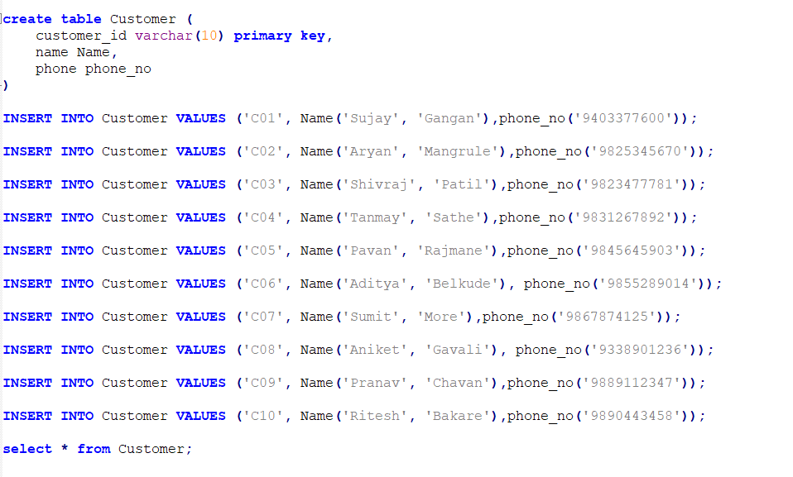

Creating Book_Sale Table:

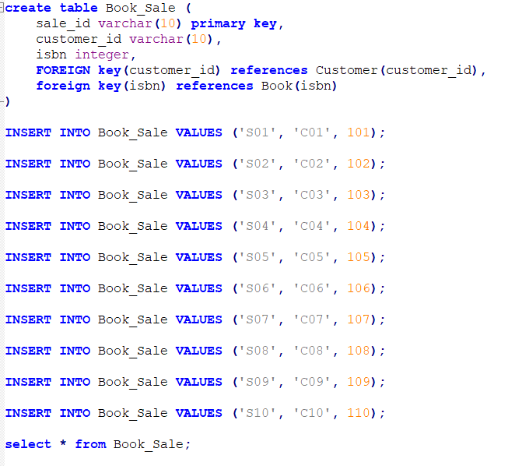

Queries:

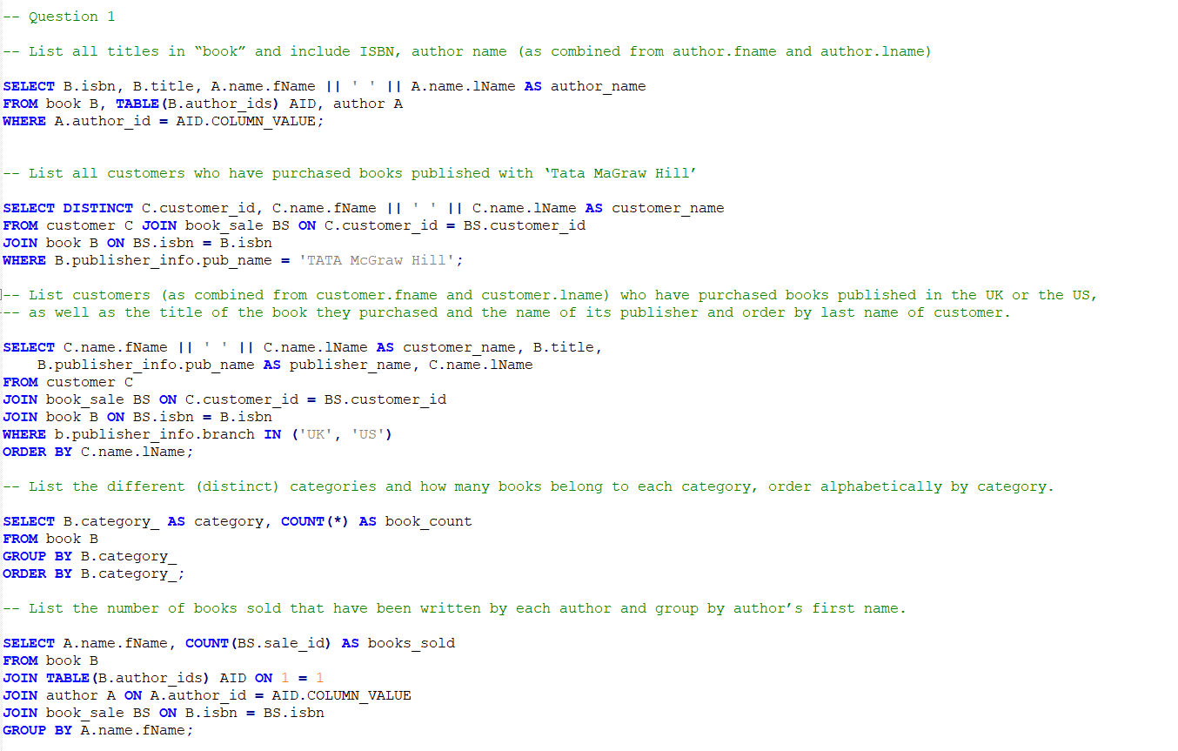

**Problem Statement 2:**

Consider a database schema with a relation Emp whose attributes are as shown below, with types specified for multivalued attributes.

Emp= (ename, ChildrenSet multiset(Children), SkillSet multiset(Skills))

Children = (name, birthday)

Skills = (type, ExamSet setof(Exams))

Exams = (year, city)

1. Define the above schema in SQL, with appropriate types for each attribute.

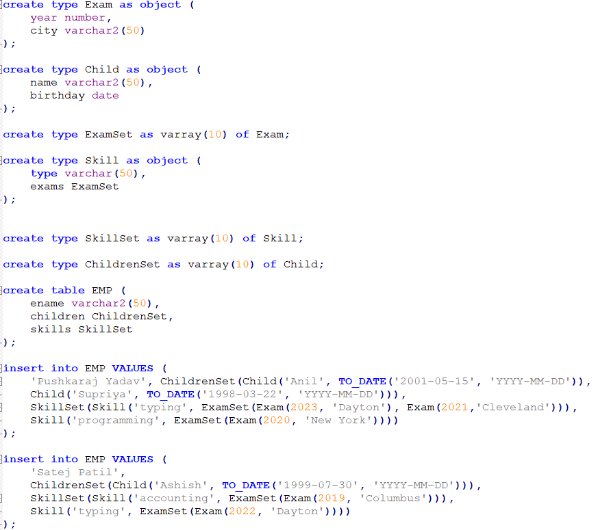

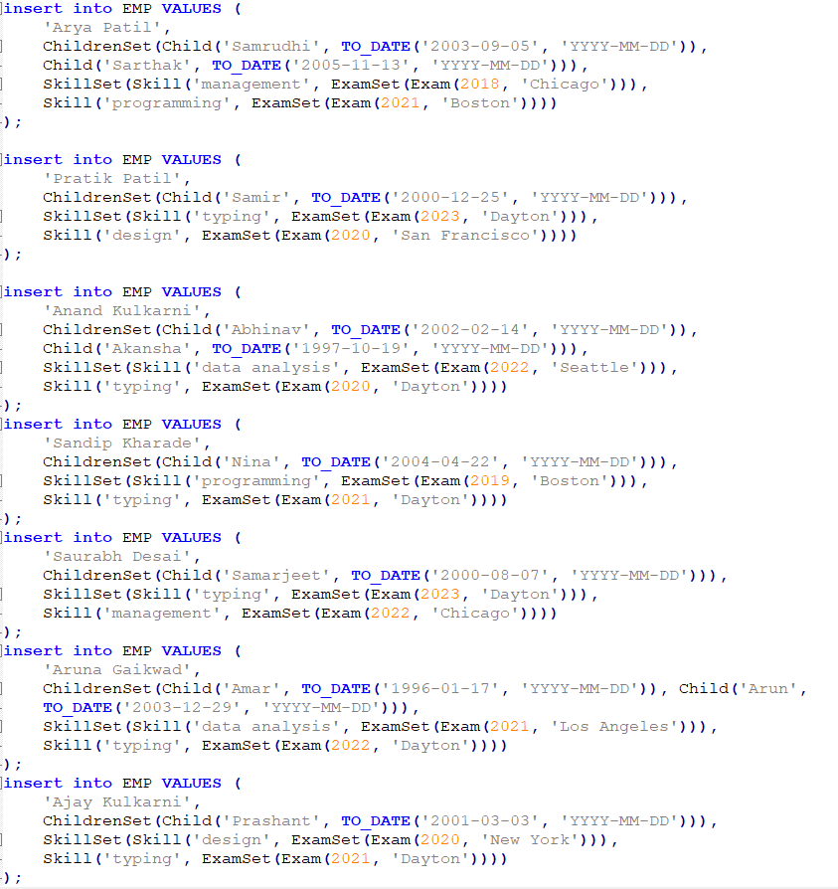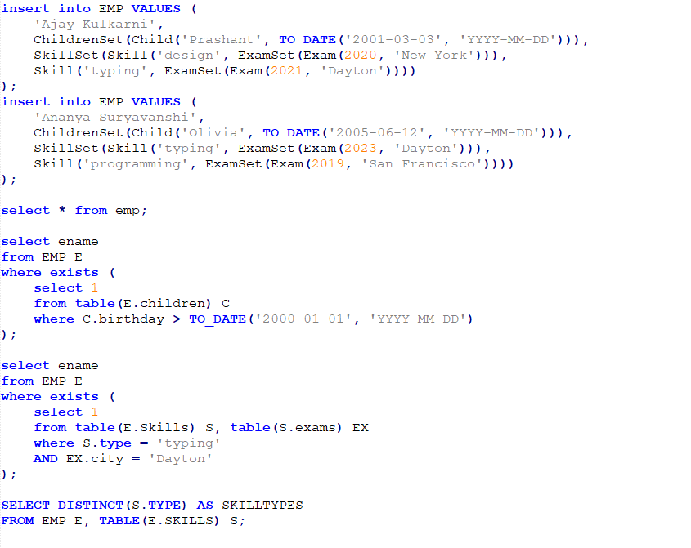

**B.** Using the above schema, write the following queries in SQL.

* + 1. Find the names of all employees who have a child born on or after January 1, 2000.
    2. Find those employees who took an examination for the skill type “typing” in the city “Dayton”.
    3. List all skill types in the relation Emp.

